
NAME: M NASEEM
ROLL NO: 055
SECTION: BSSE-4A
SUBJECT: AI(lab)
SUBMITTED TO: RASIKH ALI

A* ALGORITHM – MANUAL CALCULATION OF g(n), h(n), AND f(n)
1. Introduction
A* is a search algorithm used to find the shortest or lowest-cost path from a starting point to a destination, to a noticeable degree, in actual application.
It employs three values:
g(n): Actual cost from the starting point to the current node.
h(n): Estimated cost from the current node to the destination.
f(n): Total estimated cost.
Formula:
f(n)=g(n)+h(n)
2. Given Graph
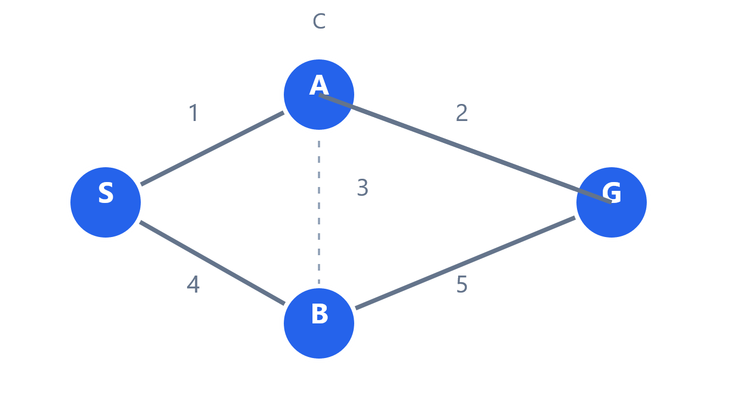
Starting node = S
Goal node = G
Edge costs:
Edge | Cost
S → A | 1
S → B | 4
A → C | 2
B → G | 5
C → G | 3

Heuristic values:
Node | h(n)
S | 5
A | 4
B | 4
C | 2
G | 0

3. Manual Calculation (First Three Expansions)
Step 1: Expand S
Let's start, we start from S.
g(S)=0
h(S)=5
f(S)=0+5=5
Now find the connected nodes:
A: g = 0+1 = 1
h = 4, f = 1+4 = 5
B: g = 0+4 = 4
h = 4, f = 4+4 = 8
Frontier after expanding S:
Node | g | h | f
A | 1 | 4 | 5
B | 4 | 4 | 8

Moving on chosen, including A, because it has the lowest f-value (5).

Step 2: Expand A
For node A:
g(A)=1
h(A)=4
f(A)=1+4=5
A is currently connected to C.
Calculate C:
g(C)=1+2=3
h(C)=2
f(C)=3+2=5
Frontier after expanding A:
Node | g | h | f
B | 4 | 4 | 8
C | 3 | 2 | 5

Moving on picked, such as C, because it has the lowest f-value (5).
Step 3: Expand C
For node C:
g(C)=3
h(C)=2
f(C)=3+2=5
C is mainly connected to G.
Calculate G:
g(G)=3+3=6
h(G)=0
f(G)=6+0=6

Frontier after expanding C:
Node | g | h | f
B | 4 | 4 | 8
G | 6 | 0 | 6

And then picked - G, because it has the lowest f-value (6), and what's more, still, g is the goal, so the algorithm is stopping, in many respects.
Keep in mind: At every step, A* selects the node with the smallest f-value from the frontier, which is generally helping it find a low-cost path efficiently, on the whole.
4. Final Summary
Expansion | Selected Node | g | h | f
1 | S | 0 | 5 | 5
2 | A | 1 | 4 | 5
3 | C | 3 | 2 | 5

5. Final Path and Cost
The final path is:
S→A→C→G
Total cost:
1+2+3= 6
Alternative path:
S→B→G
4+5=9
Okay then the best path is S → A → C → G, because its total cost is usually 6, which is generally lower than the alternative path cost of 9, broadly speaking.

6. Conclusion
In this lab, i learned how the A* algorithm finds the lowest-cost path using g(n), h(n), and f(n), and found the first three expansions and gathered how A* selects the node with the lowest f-value, in actual application, and so, the best path was S → A → C → G, with a total cost of 6 units, in real-world scenarios.

